Deploy python app with cpu and ram allocation

example

3 PODS = running = 3000 users = 3 months

5 PODS = running = 5000 users = 4 months

**Step 1 : Create a horizontal pod autoscaler**

vim cpuram.yaml

apiVersion: apps/v1

kind: Deployment

metadata:

name: pythoncpu-deployment

labels:

app: python

spec:

replicas: 3

selector:

matchLabels:

app: python

template:

metadata:

labels:

app: python

spec:

containers:

- name: pythoncpu-container

image: anilbidari/python:v1

ports:

- containerPort: 80

resources:

requests:

cpu: "250m" # Request 250 milliCPU (0.25 vCPU) ###per pod level

memory: "256Mi" # Request 256 MB RAM

limits:

cpu: "500m" # Limit CPU to 500 milliCPU (0.5 vCPU) ###per pod level

memory: "512Mi" # Limit RAM to 512 MB

**step 2: create and list hpa with desired number of pods**

kubectl create -f cpuram.yaml

**Step 3 : List the deployment**

kubectl get deployments

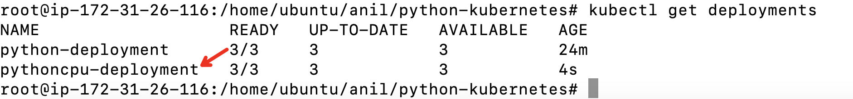

**Step. 4: describe the deployment to check it has cpu and ram allocated**

kubectl describe deployment pythoncpu-deployment

====================== lab completes ========================